| **Test #** | **Input Values (Values as input)** | **Expected Output** | **Actual Output** | **Pass or Fail** |
| --- | --- | --- | --- | --- |
| Test Scenario 1 | MENU  1: Order a Snack  2: Exit program  Enter your selection: 2 | Thank you for using the program. Goodbye! | Thank you for using the program. Goodbye! | PASS |
| Test Scenario 2 | MENU  1: Order a Snack  2: Exit program  Enter your selection: 1  Do you want Fruit Snack (1) or Salty Snack (2): 1  What size do you want: S, M, or L: S Do you want citrus fruit included? true/false: true | You have chosen snack type = Fruit Snack, of type = S, id = FRUIT-SNK-59 and price = 25.98 | You have chosen snack type = Fruit Snack, of type = S, id = FRUIT-SNK-59 and price = 25.98 | PASS |
| Test Scenario 3 | MENU  1: Order a Snack  2: Exit program  Enter your selection: 1  Do you want Fruit Snack (1) or Salty Snack (2): 1  What size do you want: S, M, or L: M  Do you want citrus fruit included? true/false: false | You have chosen snack type = Fruit Snack, of type = M, id = FRUIT-SNK-5 and price = 29.99 | You have chosen snack type = Fruit Snack, of type = M, id = FRUIT-SNK-5 and price = 29.99 | PASS |
| Test Scenario 4 | MENU  1: Order a Snack  2: Exit program Enter your selection: 1  Do you want Fruit Snack (1) or Salty Snack (2): 1  What size do you want: S, M, or L: L  Do you want citrus fruit included? true/false: false | You have chosen snack type = Fruit Snack, of type = L, id = FRUIT-SNK-38 and price = 39.99 | You have chosen snack type = Fruit Snack, of type = L, id = FRUIT-SNK-38 and price = 39.99 | PASS |
| Test Scenario 5 | MENU  1: Order a Snack  2: Exit program Enter your selection: 1  Do you want Fruit Snack (1) or Salty Snack (2): 2  What size do you want: S, M, or L: S  Do you want nut snack included? true/false: true | You have chosen snack type = Salty Snack, of type = S, id = SALTY-SNK-35 and price = 24.49 | You have chosen snack type = Salty Snack, of type = S, id = SALTY-SNK-35 and price = 24.49 | PASS |
| Test Scenario 6 | MENU  1: Order a Snack  2: Exit program Enter your selection: 1  Do you want Fruit Snack (1) or Salty Snack (2): 2  What size do you want: S, M, or L: M  Do you want nut snack included? true/false: false | You have chosen snack type = Salty Snack, of type = M, id = SALTY-SNK-21 and price = 29.99 | You have chosen snack type = Salty Snack, of type = M, id = SALTY-SNK-21 and price = 29.99 | PASS |

**Test Scenario 1 Screenshot(s)**

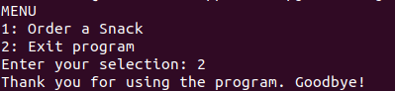

**Test Scenario 2 Screenshot**

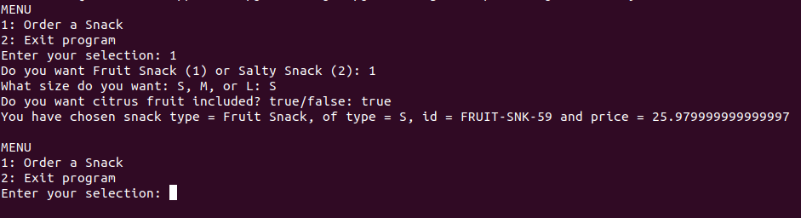

**Test Scenario 3 Screenshot**

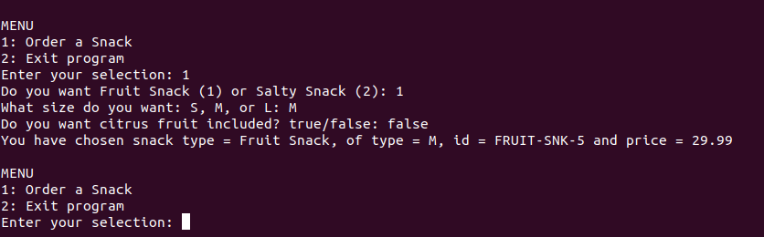

**Test Scenario 4 Screenshot**

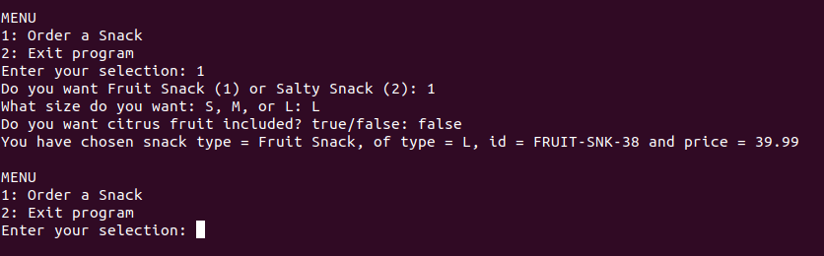

**Test Scenario 5 Screenshot**

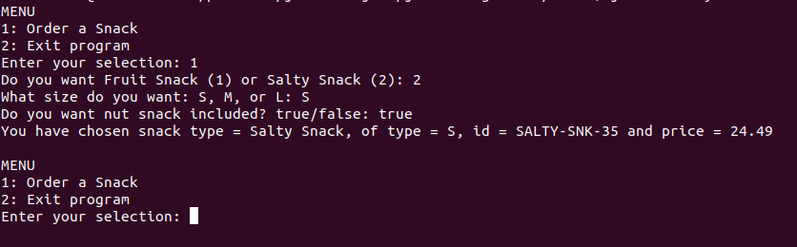

**Test Scenario 6 Screenshot**

